Nama : widya Kusuma wardani

Nim : 071911633048

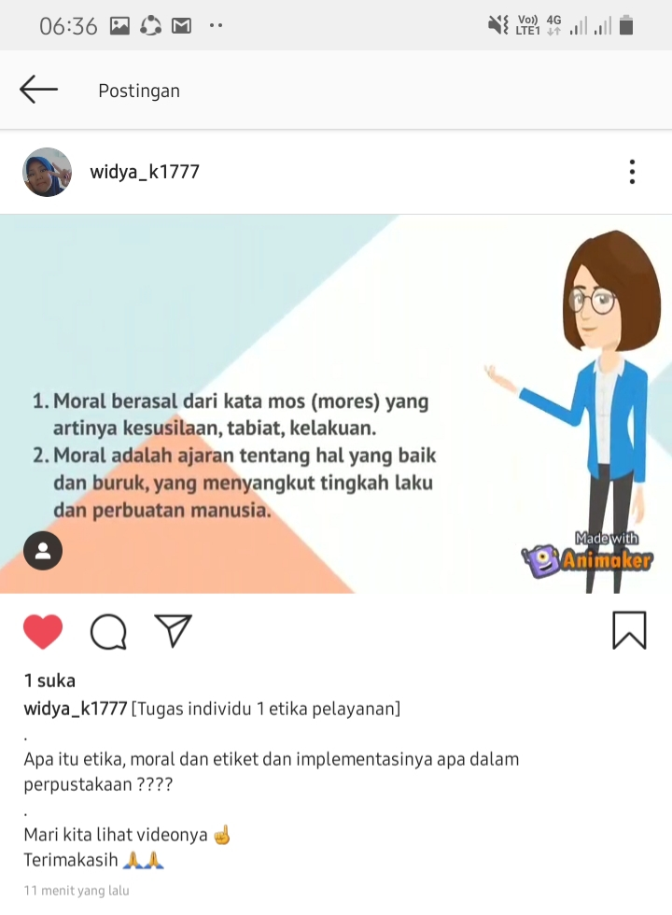

<https://www.instagram.com/p/CFA7ykunsZZ/?igshid=oh122elbhz0g>

Alamat Tiktok dan IG :

Tiktok : widyawardani3 <https://t.tiktok.com/i18n/share/user/6682263661975634945/?_d=dbf3e798ki3hfi&language=id&sec_uid=MS4wLjABAAAAvk_QIVGHAyEuMkKrFqRL_JshSbKorCCQ6fG3mwUsWM4-ZUTp1Q-5N_RcGKz-3Pgf&share_author_id=6682263661975634945&u_code=d5l50lfad7amlg&timestamp=1599800264&user_id=6682263661975634945>

IG : widya_k1777